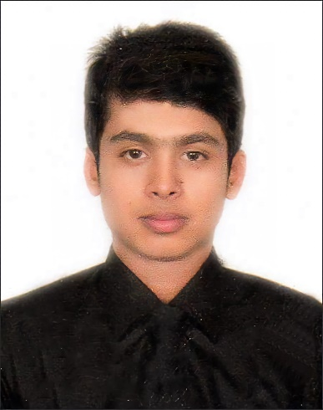

As a motivated CSE student, I'm enthusiastic about IT and research, with a solid background in programming, data structures, and algorithms & eager to apply my skills in an internship setting, dedicated to problem-solving, teamwork, and contributing to your organization 's success while expanding my knowledge and expertise in the field.

**BSc in CSE**

**Arafat Islam**

**Contact Information**

**Education**



**Programming Skills**

* **2019 – present American International University-Bangladesh.**

BSc in CSE. (Last semester)

* **2016 – 2018** **Cambrian School & College.**

Higher Secondary Certificate (HSC).

* **2014 – 2016** **Nangalkot A.R. Model Govt. High School**

Secondary School Certificate (SSC).

***[/](https://www.linkedin.com/in/aarafat27/)******[in/aarafat27](https://www.linkedin.com/in/aarafat27/)***

***[/aarafat27](https://github.com/aarafat27)***

***[/@aarafat27](https://medium.com/@aarafat27)***

***[arafatedu11@gmail.com](mailto:arafatedu11@gmail.com)***

***01709009187, 01318805474***

***Kuratoli, Khilkhet, Dhaka 1229***

**Skills**

* Programming.
* Problem solving.
* Object oriented analysis and design.
* UI Design.
* Presentation.
* Leadership.
* Punctuality.
* Teamwork.
* Understandability.

**Tools**

* GitHub
* Tortoise SVN
* PowerPoint
* Word
* Excel
* **PHP**
* **JavaScript**
* **Oracle SQL**
* **JAVA**
* **Python**
* **C#**
* **C**
* **C++**
* **Fire Detection (computer vision):**
* Detects fire from real-time videos and images.
* Developed using **YOLOv5x** a CNN based Deep learning real-time object recognition algorithm.

**Technologies:** Python, YOLOv5x, PyTorch, Google Collab.

*[More at GitHub →](https://github.com/aarafat27/Fire-Detection-Using-YOLOv5)*

* **Heart Disease Prediction (machine learning):**
* Predict heart disease from patient’s medical data like age, sex, chest pain type, resting BP, cholesterol, fasting BS, resting ECG etc.
* Developed using different ml model- SVM, KNN, Decision Tree, Logistic regression & Naive bayes.

**Technologies:** Python, Jupyter Notebook, Scikit-Learn, Numpy, Pandas, Matplotlib, Seaborn.

*[More at GitHub →](https://github.com/aarafat27/Heart-Disease-Prediction)*

* **Cafe Management System (service):**
* A complete cafe management system.

**Technologies:** C#, .NET, Microsoft Visual Studio.

*[More at GitHub →](https://github.com/aarafat27/Cafe-Management-System)*

* **Go-Green E-Nursery (e-commerce):**
* A marketplace for plants and trees.

**Technologies:** PHP, HTML5, CSS, JavaScript, Bootstrap, VS Code, XAMPP

*[More at GitHub →](https://github.com/aarafat27/Go-Green-E-Nursery)*

**Projects**

**Research Interests**

* Artificial General Intelligence
* Blockchain
* Computer Vision
* Machine Learning
* Deep Learning
* Graph Theory
* Software Quality & Assurance Engineering.

**Tools**

* GitHub
* Pycharm
* Jupyter Notebook
* Figma
* MATLAB
* Cisco Packet Tracer
* NI Multisim
* Arduino IDE
* Draw.io
* Microsoft Office
* Google Colab